

Registered Charity No: Issue 3 - December 2017
(Pending)

NEWSLETTER

75A Ringwood Road
Poole, Dorset, BH14 0RG,
Telephone: 07948 469192
Email: admin@tylersfriends.co.uk
www.tylersfriends.co.uk

Dear Tyler's Friends,

Welcome to the third issue of Tyler's Friends newsletter.

This issue reveals all about the very successful quiz night, the date for the Woman's Well-Being Christmas party, our next event in January and also how successful our November challengers were.
A big thank you to those who have set up a monthly standing order, your support means a great deal to us.

We are now in a position to start helping bereaved families, which is fantastic. Please get in touch if you have any ideas on how we can continue raising money each month.

24th November 2017 - Quiz Night / Raffle and Auction

The quiz night was a roaring success. A huge thank you to everyone who joined us and to those who donated raffle prizes. The winning team was Action Heroes and Katie Bass was the highest bidder in the auction and now has a long weekend in Goodrington, Torquay to look forward to. A massive total of £1,021.31 was raised. We hope you enjoyed the night and we look forward to seeing you at our next quiz night sometime next year.

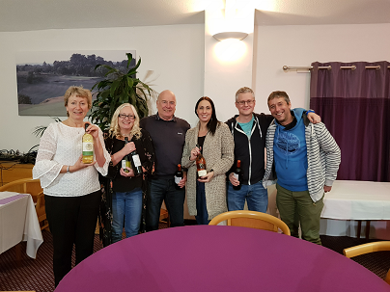

Kirsten donated a total of £21 which was a combination of lb and inches lost during November and Natasha donated £26 as she went 26 out of 30 days without having a take-away. Fantastic effort from you both, so thank you very much for your contribution by completing your own monthly challenge.

December 2017 - Christmas Party

The Woman's Well-Being Group at Poole will be holding a Christmas party (mince pies, disco, party games, carols and much more) on Friday 22nd December from 3pm and as you know are donating 50% of money raised to Tyler's Friends, so please pop along and show your support if you are free. You will find them at 75a Wimborne Road, Poole, BH14 0RG. We will let you know how much was raised in our January issue.



Our December challenger is Jon Rust who is going to see how many days during December he can go without a Costa coffee, we won't be holding our breath on this one!!

We will be collecting and counting up the 5p and loose change challenge this month. So please make sure you've handed yours in by the end of the year. The grand total will be revealed in our January issue.

21st January 2018 - Sherford Bridge to The Silent Woman

Our next mini walk has been decided. A nice walk across Wareham Forest over to The Silent Woman pub for a refreshing drink before returning on the same route. This is a 5 and a half mile walk, children and dogs are of course very welcome. Entry fee will be £5 per adult - £2 per child and £1 per dog. If you would like to join us then please let us know. All information can be found on our facebook page.



Merry Christmas and a Happy New Year to you all and thank you for your continued support.
Love from us all at Tyler's Friends

